RLWD Projects Partially funded by the Clean Water and Legacy Amendment
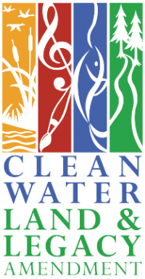
- All One Watershed One Plan Projects and Watershed-Based Implementation Funding
  - 149 – Red Lake River One Watershed One Plan
  - 149A – Thief River One Watershed One Plan
  - 149B – Clearwater River One Watershed One Plan
  - 149C -Upper Red Lake One Watershed One Plan
- Surface Water Assessment Grant Sampling
  - 168A (all Cycle 2)
  - 157CC
  - 157EE
- 46Q TRF Oxbow
- 46S Chief’s Coulee
- Polk County Ditch 99 Outlet Stabilization
- All Cycle 1 and Cycle 2 WRAPS and TMDLs
  - 157B – Thief River Watershed Assessment Project
  - 157C – Red Lake River Watershed Assessment project
  - 157E - Clearwater River Watershed Restoration and Protection Project - WRAP
  - 157F - Upper and Lower Red Lakes Watershed Restoration and Protection
- 2026 Flage project repairs
- TRF Westside FDR Outlet Stabilization
- 2021-2026 Thief River streambank stabilizations
- 180B Agassiz Pool Silt Removal – JD11 Conservation Partners Legacy Grant
- Side water inlets along
  - Project 179
  - Polk Co Ditch 39
  - RLWD Ditch 17
- Side Water Inlets and rock grade stabilization structures along the Black River Impoundment’s diversion ditches
- 2025 JD21 grade stabilization
  - 149A0
- Clearwater River Stabilization Project
  - 149B
- 60FF – Grand Marais Creek Cut-Channel Stabilization
- 14D – CD 20 Grade Stabilization
- Huot Streambank Project CPL Grant
- Ditch 10 outlet stabilization
- Burnham Creek Watershed Restoration Project, Phase I

